**SQL EXERCISE – 09/07/2021**

**/*Creating Table*/**

**create** **table** Table1Sruthi(

A_Id **int** **primary** **key**,

A_Name **varchar**(20),

A_Contact **varchar**(10),

A_DOB **date**

)

**Alter** **table** Table1Sruthi

**Add** A_Grade **char**;

**/*Inserting values*/**

**insert** **into** Table1Sruthi

**values** (1,'sam','9876543210','1989-10-5','A'),

(2,'mark','9890236548','1997-1-7','F'),

(3,'rick','9987543218','1895-11-8','E'),

(4,'fred','9876598745','1984-5-12','C'),

(5,'gray','9888856972','1981-6-17','B'),

(6,'Michel','9874563214','2010-5-5','A');

**/*Creating Table*/**

**create** **table** Table2Sruthi(

B_Id **int** **primary** **key**,

A_Id **int**,

B_Region **varchar**(20),

B_Phone **varchar**(10),

B_Date **date**,

**Foreign** **Key** (A_Id) **References** Table1Sruthi(A_Id)

);

**Alter** **table** Table2Sruthi

**Add** A_Initial **char**;

**/*Inserting values*/**

**insert** **into** Table2Sruthi

**values** (11,5,'India','9888856972','1989-8-5','B'),

(12,1,'Us','9876543210','1997-12-7','F'),

(13,6,'Uk','9874563214','1895-1-8','E'),

(14,2,'France','9890236548','1984-4-12','C'),

(15,3,'Australia','9987543218','1989-11-2','A');

**Update** Table2Sruthi

**set** B_Region = 'India'

**where** B_Id = 15;

**Update** Table2Sruthi

**set** A_Initial = 'A'

**where** B_Id = 13;

**/*Display tables*/**

**select** * **from** table1sruthi

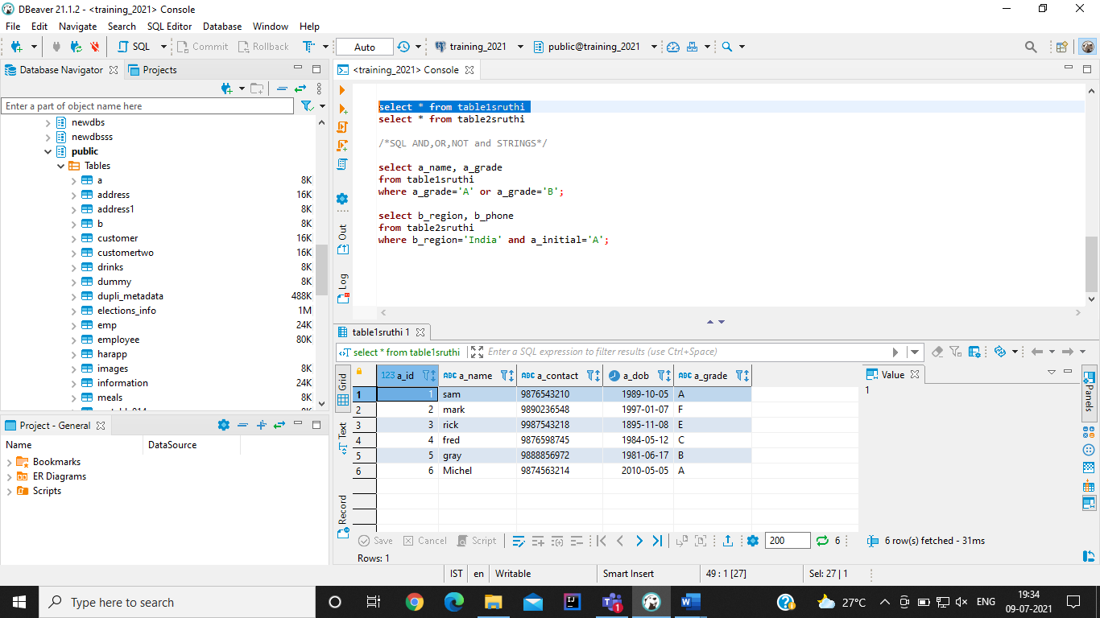

**select** * **from** table2sruthi

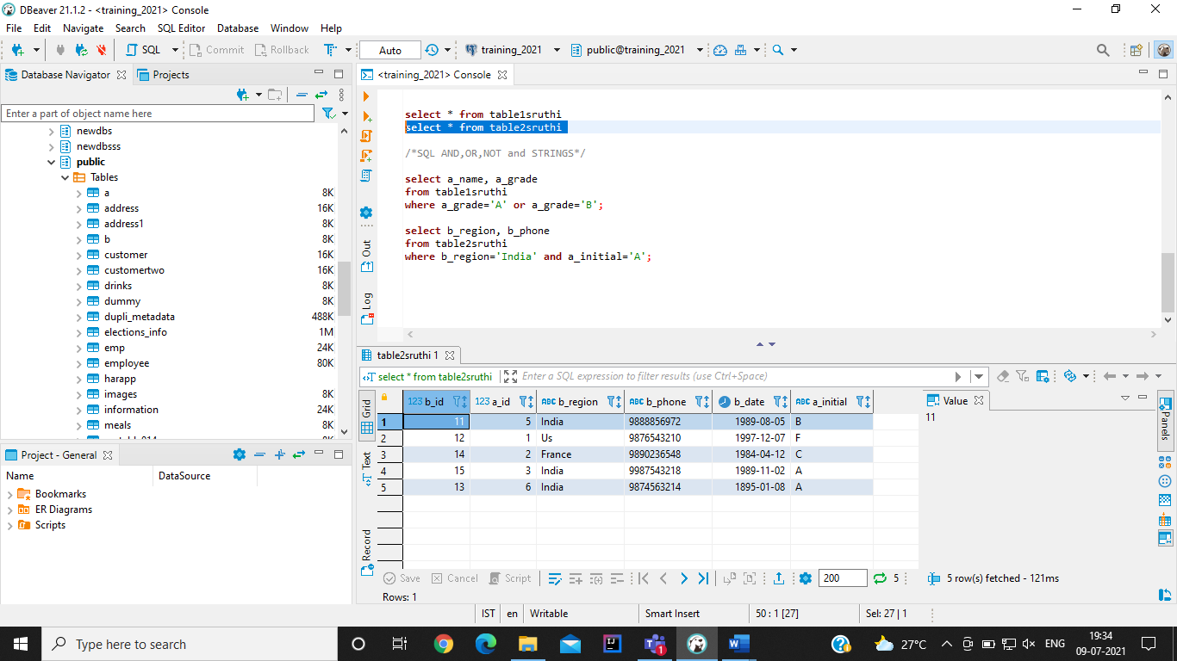

**/*SQL AND,OR,NOT and STRINGS*/**

**select** a_name, a_grade

**from** table1sruthi

**where** a_grade='A' **or** a_grade='B';

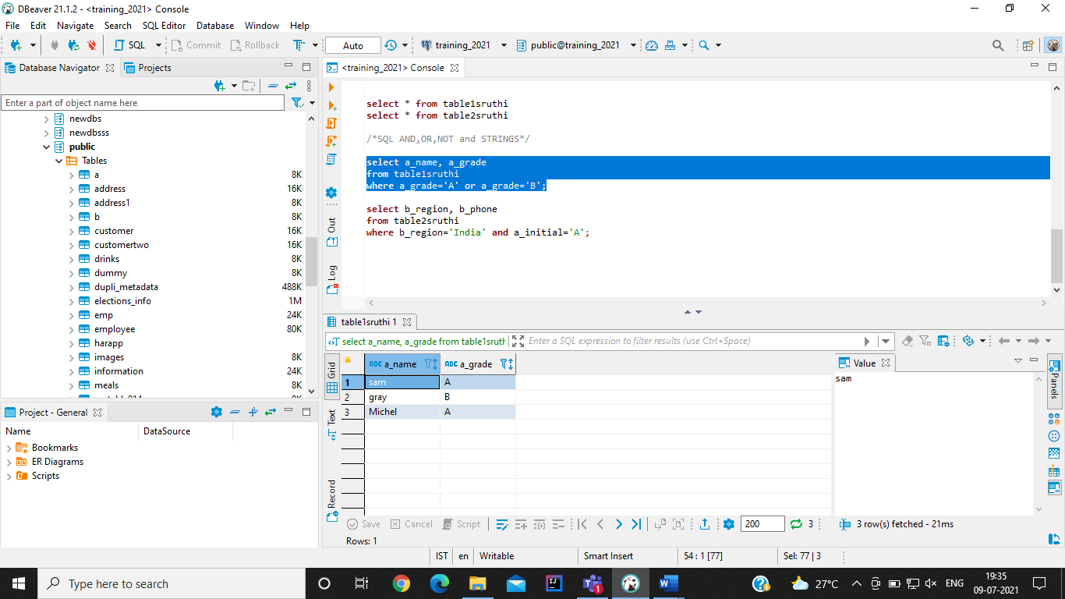

**select** b_region, b_phone

**from** table2sruthi

**where** b_region='India' **and** a_initial='A';

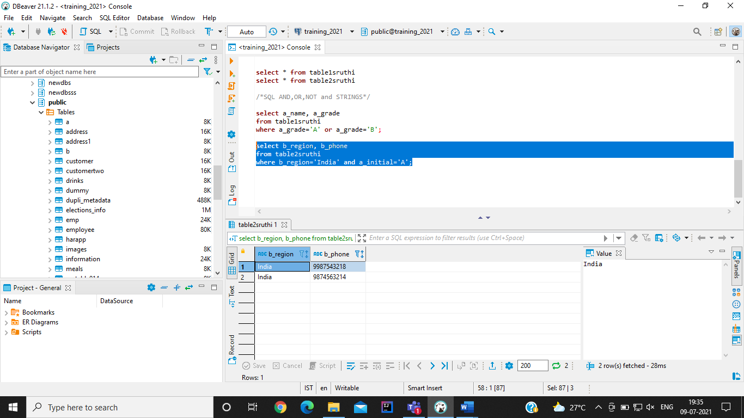

**select** b_region, b_phone

**from** table2sruthi

**where** **not** b_region='India'

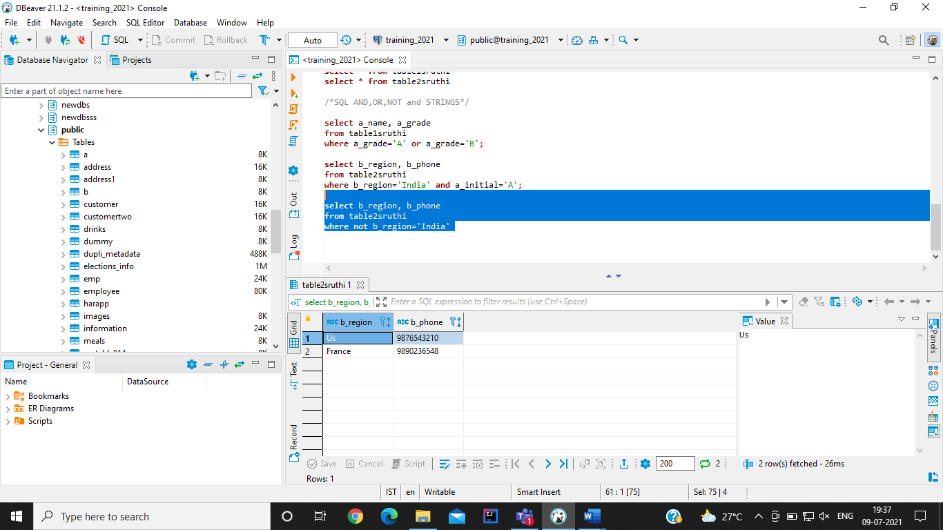

**select** a_name

**from** table1sruthi

**where** a_name **LIKE** '%k'

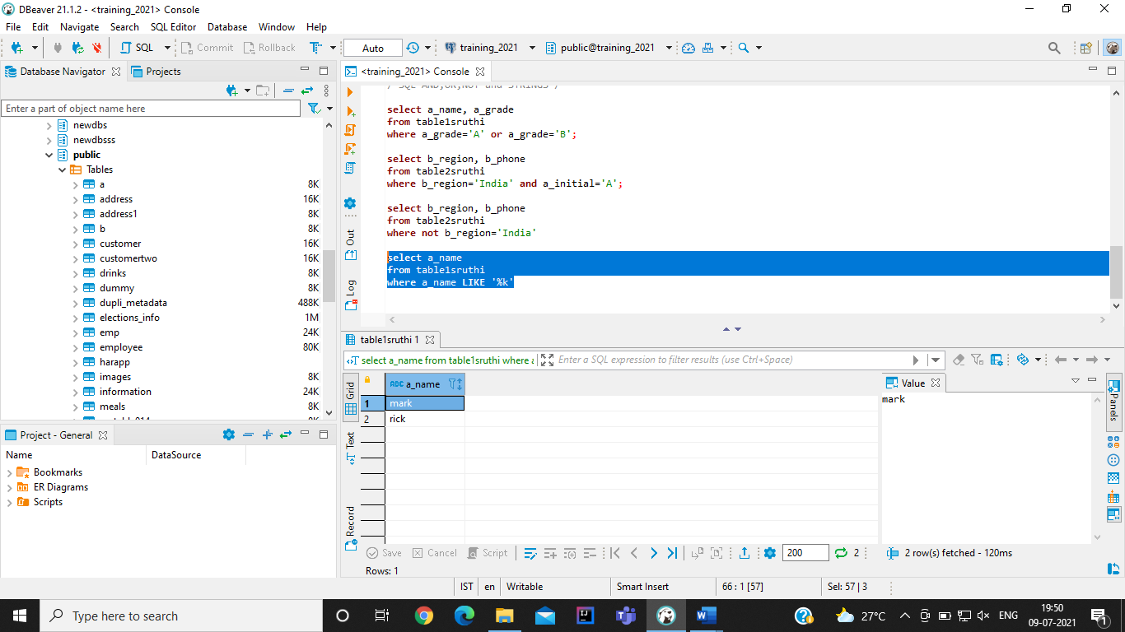

**/*Aggregate Functions*/**

**/*MIN, MAX, COUNT, SUM, AVG, DISTINCT*/**

**select** **count**(b_id)

**from** table2sruthi

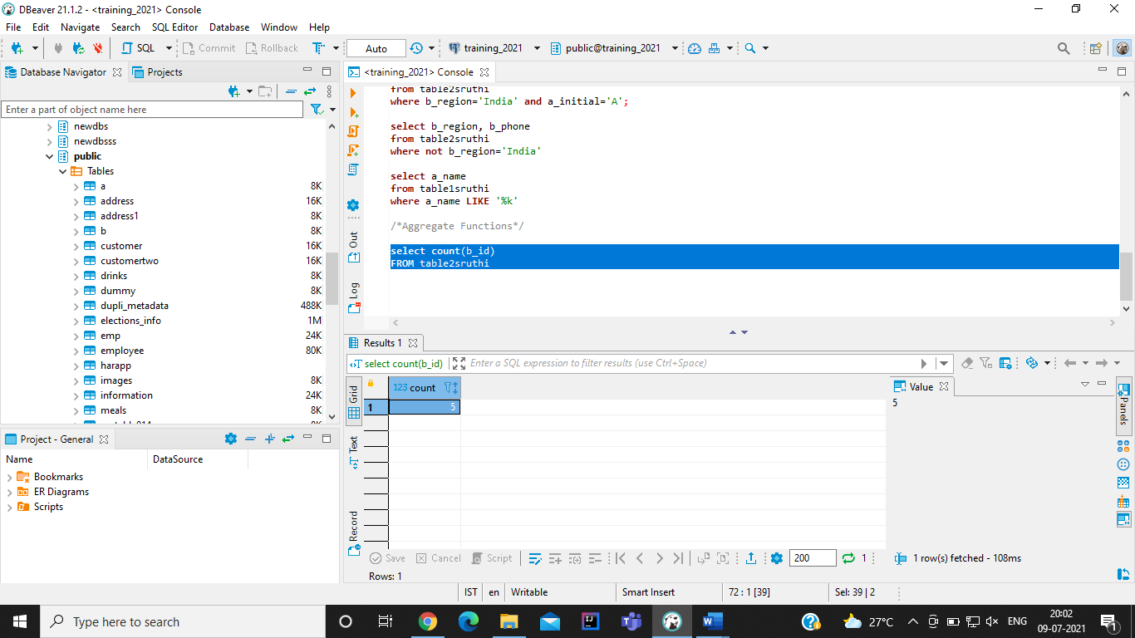

**select** **Distinct**(b_region) **as** Region

**from** table2sruthi

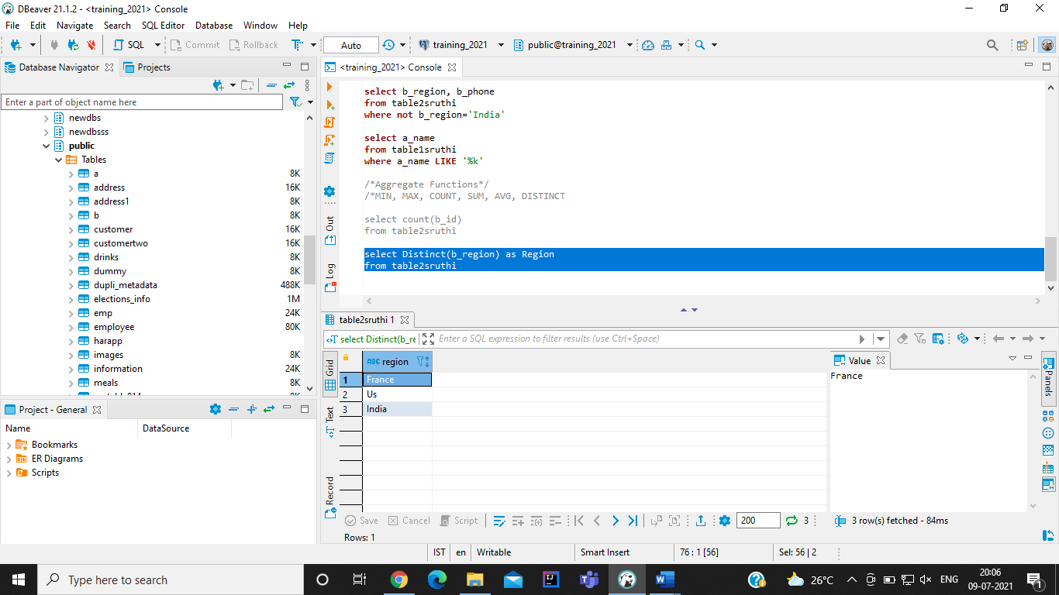

**/* IN, NOTIN and BETWEEN, NOTBETWEEN */**

**select** * **from** table2sruthi

**where** b_region **in** ('India', 'France', 'Uk');

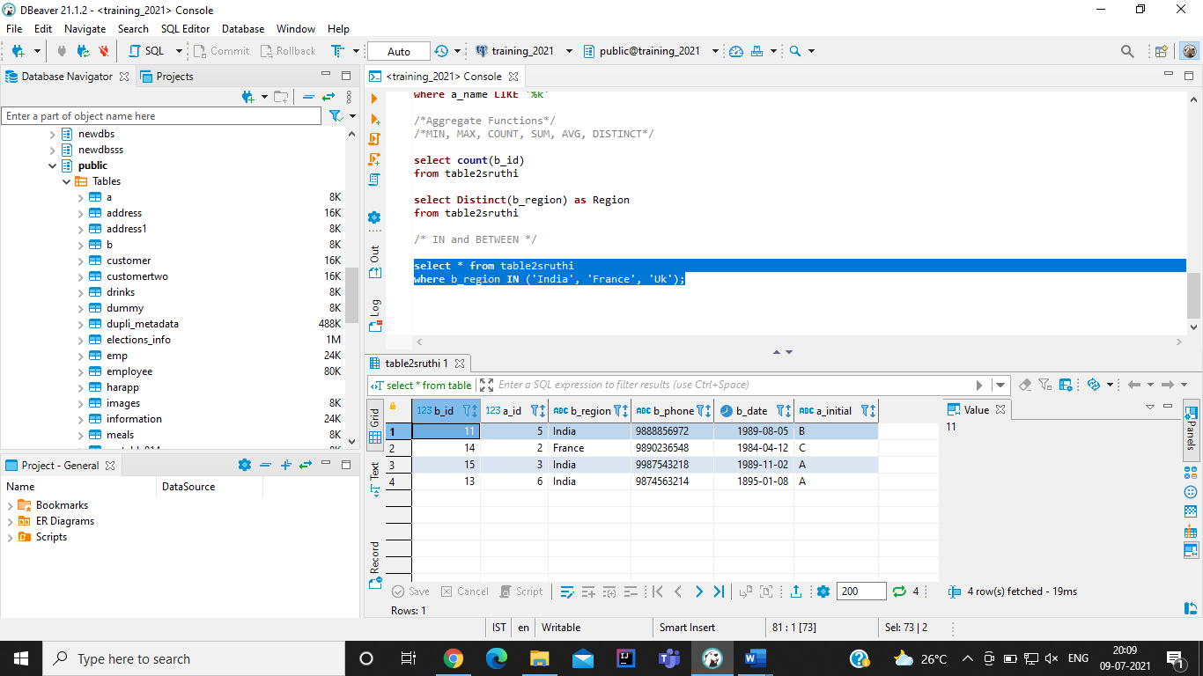

**select** * **from** table2sruthi

**where** b_region **not** **in** ('India', 'France', 'Uk');

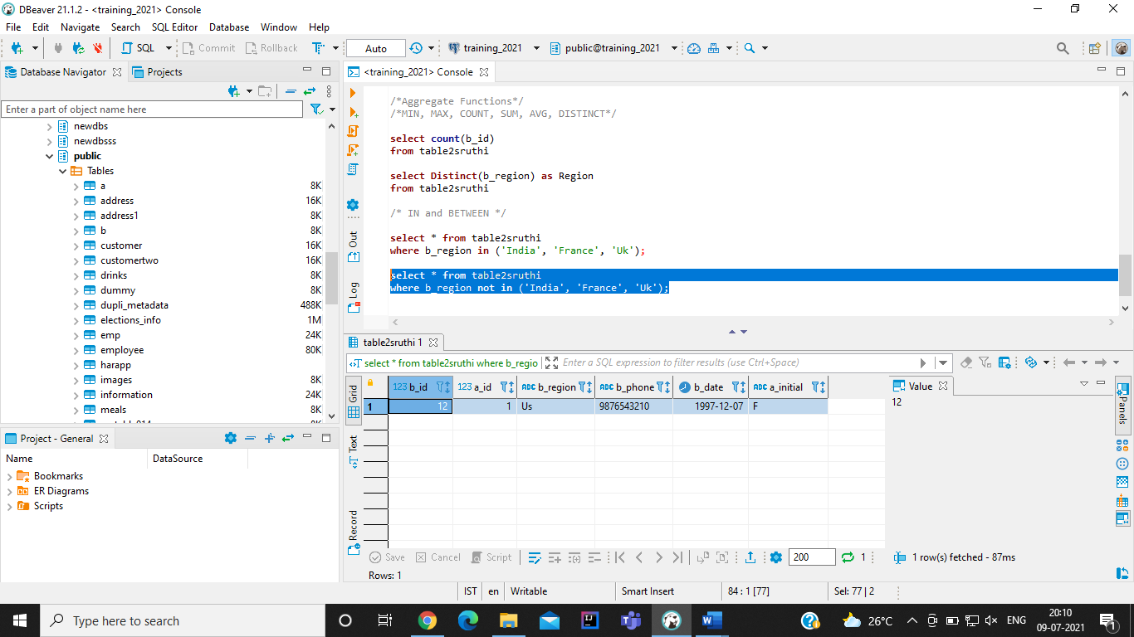

**select** a_name, a_contact

**from** table1sruthi

**where** a_id **between** 3 **and** 5

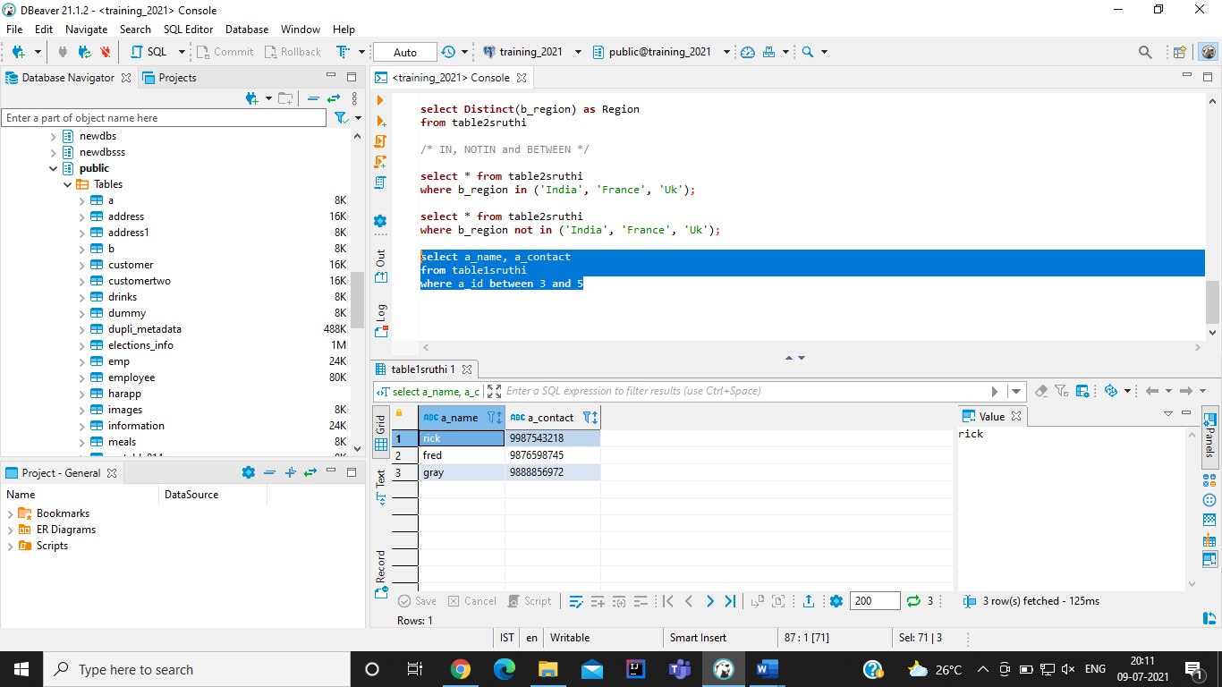

**select** a_name, a_contact

**from** table1sruthi

**where** a_id **not** **between** 3 **and** 5

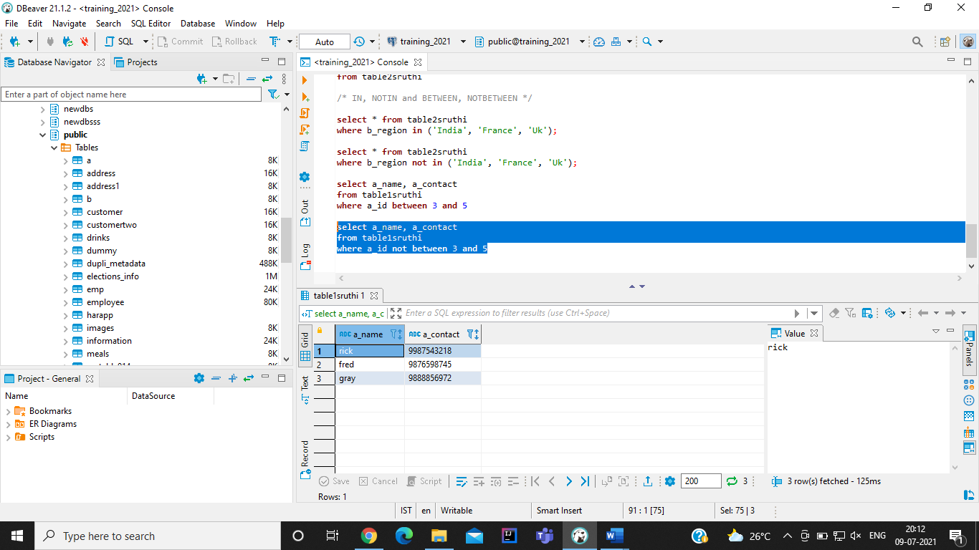

**/*UNION and UNION ALL*/**

**select** a_id **from** table1sruthi

**union**

**select** a_id **from** table2sruthi

**order** **by** a_id;

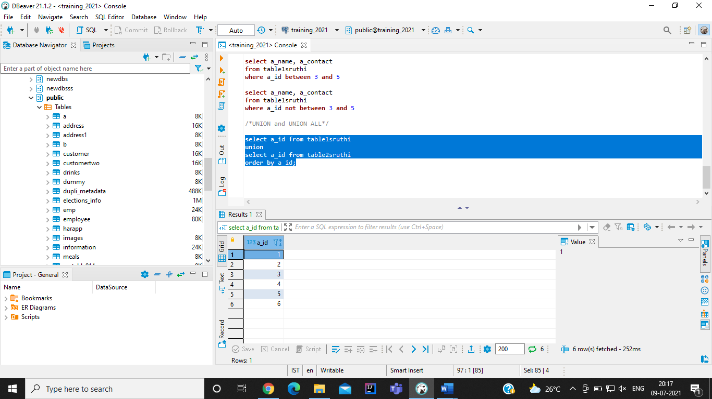

**select** a_id **from** table1sruthi

**union** **all**

**select** a_id **from** table2sruthi

**order** **by** a_id;

